@theland | Safer Recruitment Policy
Single Central Record, recruitment checks, governance and compliance
1. Purpose
This policy sets out the organisation’s commitment to safer recruitment and to maintaining a robust, accurate and up-to-date Single Central Record (SCR). It is designed to ensure that all adults working in or on behalf of the organisation are suitable to work with children and that all recruitment, vetting and checking processes are completed in line with statutory safeguarding guidance.
2. Scope
This policy applies to all employees, governors or trustees, volunteers, agency workers, contractors, supply staff, consultants and any other adults who may work with or have access to children as part of the organisation’s activities.
3. Statutory Guidance and Legal Framework
The organisation will maintain recruitment and vetting arrangements in line with current statutory guidance, including the Department for Education’s Keeping Children Safe in Education guidance, relevant safeguarding legislation, employment law, DBS requirements, right to work requirements and any sector-specific regulatory expectations.
4. Safer Recruitment Principles
Recruitment decisions will prioritise the safeguarding and welfare of children.
All recruitment processes will include appropriate scrutiny of identity, suitability, qualifications, employment history and references.
At least one person involved in shortlisting and interview panels will hold a current safer recruitment certificate wherever required or expected by the organisation.
Any gaps, discrepancies or concerns identified during recruitment will be explored, recorded and risk assessed before an appointment is confirmed.
No person will start work until all required pre-employment checks have been completed, reviewed and recorded, unless a formally approved risk assessment is in place where legally permissible.
5. Single Central Record Requirements
The SCR will be maintained as the organisation’s central safeguarding record of recruitment and vetting checks. It must be accurate, complete, current and available for inspection or audit by authorised personnel.
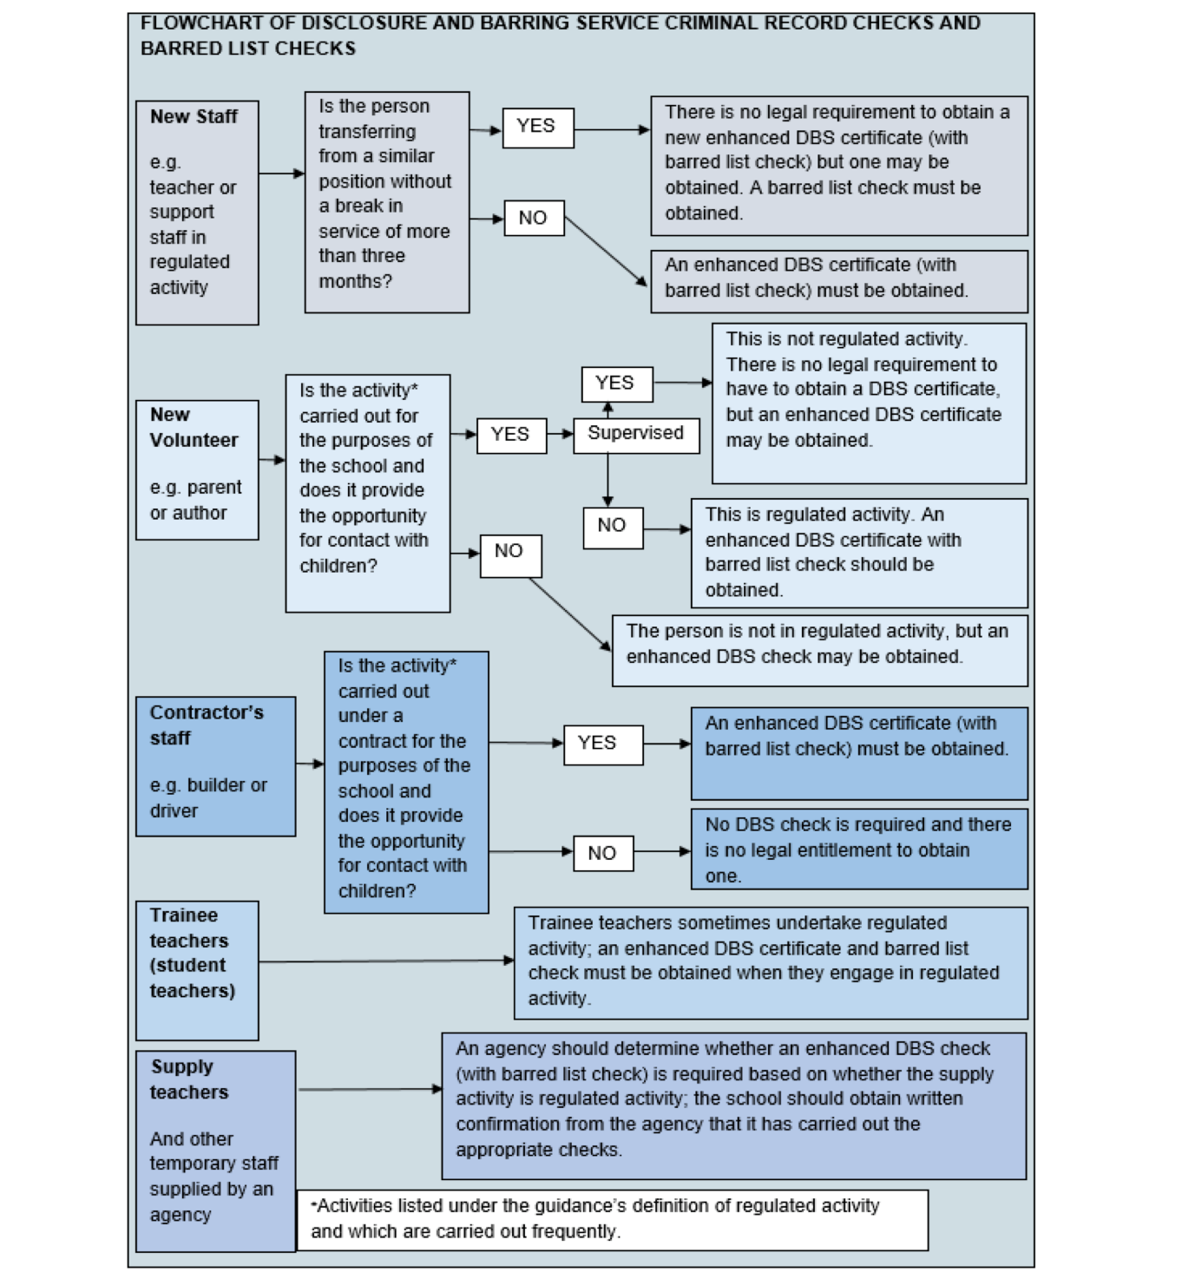

Version 1- Reviewed Aug 2026- L. Carroll
Next review date Aug 2027

