@
Support all staff who attend with pupils
theland
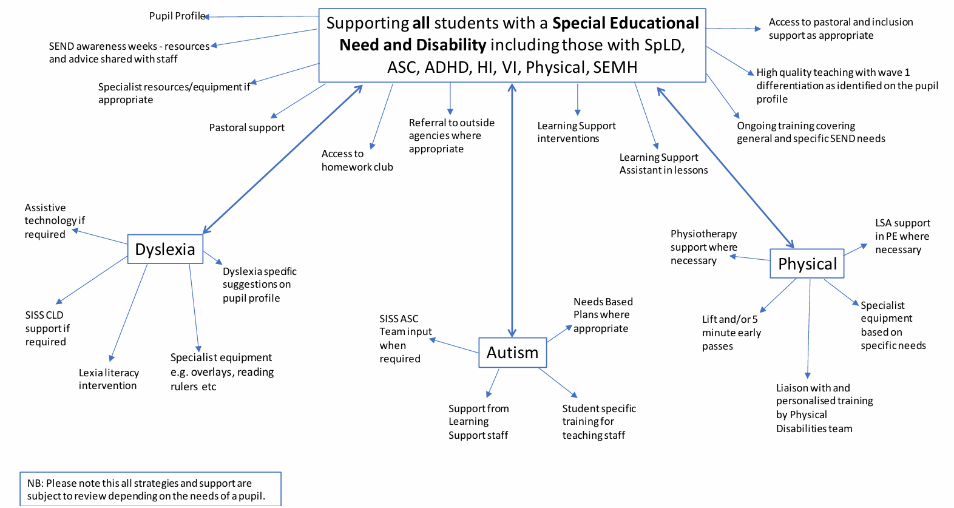
Reviewed Aug 2026
Next review Aug 2027
Help with formal or informal documentation and guidance where to/ how to progress. Support completing documentation and providing witness statements or professional statements.
Refer to Equine therapist, counsellor, occupational therapist, SALT referral.
Take direction from parents where appropriate

