@theland | Fire Evacuation Policy
This fire evacuation policy outlines the procedures for safely evacuating a building or the land in the event of a fire. It includes clear instructions, marked escape routes, and designated assembly points, along with training for all occupants on how to respond in an emergency.
In an event of a fire call 999 and request the fire brigade. Contact Laura on 07969049854 if not present
Key Components of a Fire Evacuation Policy:
Fire Emergency Evacuation Plan (FEEP):
This is a written document outlining the specific actions to be taken when a fire alarm sounds, including evacuation procedures, roll call, and contacting emergency services.
- Fire extinguishers located on yard. Fire blanket located in
- Do not attempt to put fires out yourself.
- All visitors, staff, volunteers and pupils are to be briefed about fire evacuation policy during safety briefing at beginning of all sessions/ visits/ attendance on site.
Clear Escape Routes:
These should be clearly marked, as short and direct as possible, and free from obstructions. See Map.
Designated Assembly Points:
A safe location outside the building where everyone can gather after evacuation.
Training and Drills:
Regular fire drills and training for all occupants to ensure familiarity with evacuation procedures.
Emergency Doors:
Properly functioning emergency doors that open easily for quick escape.
Emergency Lighting:
If needed, to provide guidance during evacuation if regular lighting fails.
Consideration for Special Needs:
Planning for individuals who may need assistance during evacuation, such as wheelchair users or those with visual impairments.
Fire Warden/Duty Officer:
A designated person (management) are responsible for overseeing evacuation, checking that areas are cleared, and reporting to the assembly point.
Communication:
Clear communication of the evacuation plan and procedures to all occupants, including new staff and visitors and those starting in a new location.
Responsibilities:
Clearly defined roles and responsibilities for fire wardens and other staff members.
Immediate Evacuation:
Evacuate immediately when the fire alarm sounds and do not return until authorized.
Do Not Stop to Collect Belongings:
Prioritize safety and leave the building and land as quickly as possible.
Close Doors:
Close doors behind you when evacuating to help contain the fire and smoke.

The policy will be reviewed annually
Next date for review August 2026

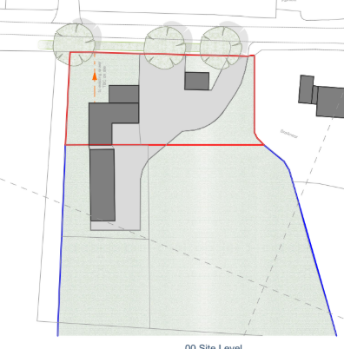
Birds eye view of premises @theland
Fire blanket located inside food store
2x Fire extinguishers located outside stables
Assembly point clearly marked at entrance.
Exits from building and assembly point at front gate

